Parish of Central Exeter
Remembrance Sunday, the third Sunday before Advent
12 November 2023

Reflection by Sheila, intercessions from Helen. Many thanks.

Welcome everyone.

The readings appointed for today are not linked to a theme of remembrance, however given the nature of the conflicts that are currently active in our world, we cannot ignore those who have died through human agency either in the past or, as is quite possible, even as you read this.

The first three elements of this service make up an act of remembrance. You can choose to use them at any time. If you wish to light a candle, we suggest you do so before you start.

Opening Prayer
Let us be aware of the voices clamouring to be heard on Remembrance Day:

those who demand that gratitude be shown to those who have made the supreme sacrifice and given lives for sovereign and country;

those to whom this is irrelevant past history;

those who wish to remember and expect others to do so;

those for whom today is but a re-opening of wounds and a delay in healing;

those who glory in war and those who loathe it;

those who see war as a cruel necessity and those who see it as an evil in which no-one should participate;

deliver us all from an insensitive polarising of attitudes. Amen
An Act of Remembrance
Let us remember before God the men and women of all nations who have died as a result of war - those who we have known and whose memory we treasure; those we never knew, and those who died unknown.
We will remember all who have lived in hope, but died in vain - the tortured, the innocent, the starving and the exiled, the imprisoned, the oppressed and the disappeared....
Let us keep silence with all who witness for peace – because the Prince of Peace is among us and is preparing to take up his cross
Silence
Prayer
Living God, by whose love we are united with one another across the boundaries of time and space, bring us to a new remembrance of your love and life, reflected in earth and sky, and every person who ever lived. Teach us to be reconciled to one another and to you, through Jesus Christ our Lord. Amen
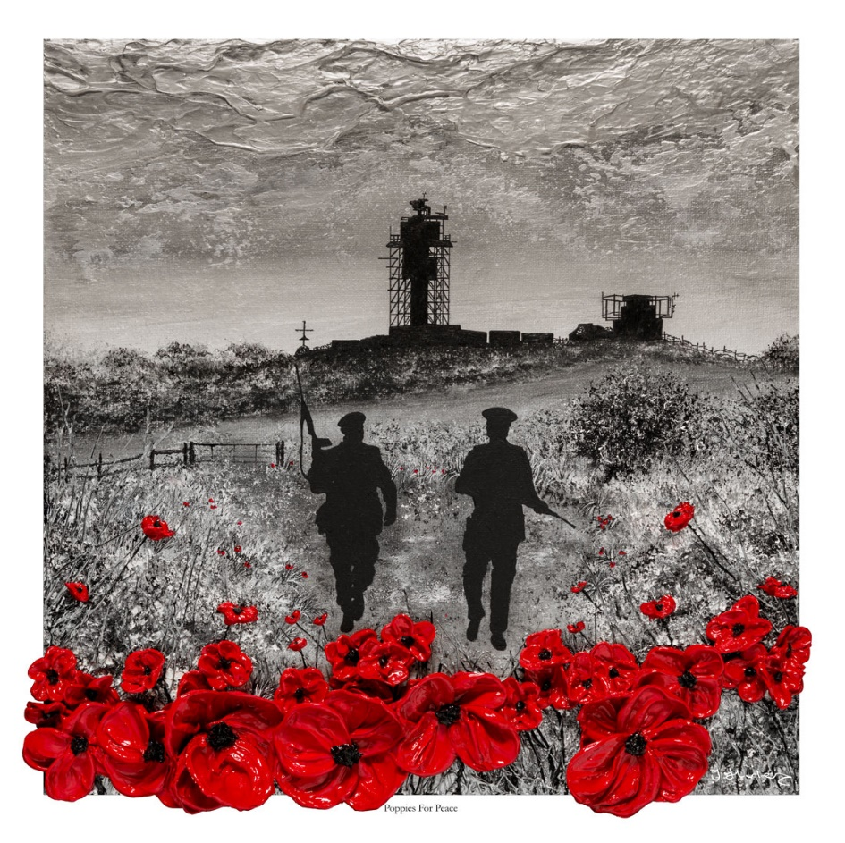

Poppies for Peace

Jacqueline Hurley

Gathering Hymn
For the healing of the nations

https://www.youtube.com/watch?v=QXtfIE6jSYQ

Collect
God, our refuge and strength,
bring near the day when wars shall cease
and poverty and pain shall end,
that earth may know the peace of heaven. Amen

New Testament Reading 1 Thessalonians 4:13-18

¹³ But we do not want you to be uninformed, brothers and sisters, about those who have died,] so that you may not grieve as others do who have no hope. ¹⁴ For since we believe that Jesus died and rose again, even so, through Jesus, God will bring with him those who have died. ¹⁵ For this we declare to you by the word of the Lord, that we who are alive, who are left until the coming of the Lord, will by no means precede those who have died. ¹⁶ For the Lord himself, with a cry of command, with the archangel’s call and with the sound of God’s trumpet, will descend from heaven, and the dead in Christ will rise first. ¹⁷ Then we who are alive, who are left, will be caught up in the clouds together with them to meet the Lord in the air; and so we will be with the Lord for ever. ¹⁸ Therefore encourage one another with these words.

Gospel Matthew 25:1-13

‘Then the kingdom of heaven will be like this. Ten bridesmaids took their lamps and went to meet the bridegroom. ² Five of them were foolish, and five were wise. ³ When the foolish took their lamps, they took no oil with them; ⁴ but the wise took flasks of oil with their lamps. ⁵ As the bridegroom was delayed, all of them became drowsy and slept. ⁶ But at midnight there was a shout, “Look! Here is the bridegroom! Come out to meet him.” ⁷ Then all those bridesmaids got up and trimmed their lamps. ⁸ The foolish said to the wise, “Give us some of your oil, for our lamps are going out.” ⁹ But the wise replied, “No! there will not be enough for you and for us; you had better go to the dealers and buy some for yourselves.” ¹⁰ And while they went to buy it, the bridegroom came, and those who were ready went with him into the wedding banquet; and the door was shut. ¹¹ Later the other bridesmaids came also, saying, “Lord, lord, open to us.” ¹² But he replied, “Truly I tell you, I do not know you.” ¹³ Keep awake therefore, for you know neither the day nor the hour.

Reflection

‘Encourage one another’ – one of the sermon series during my second curacy in Chesterfield was based on the ‘one another’ exhortations in the New Testament. (You can find a number mainly in the epistles). Here Paul encourages those first believers in Thessalonica to have hope. The resurrection of Jesus meant that those who have died and those who are alive when Christ comes again (thought to be imminent) would all be together with the Lord. This was a new idea and contrasted with the lack of belief in an after-life in the Graeco-Roman world. Though scripture provides some pictures of heaven it also leaves much unknown and held within the mystery of God. The truth about ‘being with the Lord for ever’ is the word of comfort for believers through all the ages.

How we live day by day is the important task rather than discussing any ideas about heaven. A recent reflection in BRF Guidelines on the parable of the bridesmaids put this clearly by linking this parable with Jesus’ teaching in Matthew 7:21-23 and the old chorus ‘Give me oil in my lamp, keep me burning.’ In Matthew 7:21 some people cry ‘Lord, Lord’ as the foolish bridesmaids do but both receive the word that they are not known. The explanation in Matthew 7:23 is that these people are ‘evil-doers’. If this is applied to the bridesmaids, then it suggests that the oil in the lamp refers to their holy living. So, singing that you want oil in your lamp to keep burning until the break of day is to seek more of God’s holiness in your life.

I realised that I have sung that verse many times and not really thought about it at all. This explanation made a lot of sense to me. However, the hymn book in St Stephen’s has removed that verse while keeping four other verses which outline how holy living might work out in practice. The request is for qualities in our hearts and to keep them till the end of day – all our lives. The verses are as follows:
Give me joy in my heart, keep me praising.
Give me peace in my heart, keep me resting.
Give me love in my heart, keep me serving.
Give me light in my heart, keep me shining.
This simple traditional song challenges me to keep resting on God, praising God and serving others.

Hymn

All my hope on God is founded
https://www.youtube.com/watch?v=W3LCGh02Vew&list=RDW3LCGh02Vew&start_radio=1

Lord’s Prayer
Creator God –
maker and shaper of all that is, seen and unseen;
You are in the expanse and depth of Creation,
and in the processes that make life possible.
Yet we are distracted by the gods we make ourselves
and our lives become fractured and fragmented.
In our brokenness we disturb the
Earth’s capacity to hold us.
Instead we find climate uncertainty and global injustice.
Call us back from the brink.
Help us to choose love not fear,
to change ourselves and not the planet;
to act justly for the sake of the vulnerable;
and to make a difference today for life tomorrow.
In your name - Maker, Son and Spirit. Amen

(Version by Martin Goss)

Intercessions (adapted from the Church of Scotland website)

Let us pray for all who suffer as a result of conflict and ask that God may give us peace.
For the service men and women who have died in the violence of conflict and war, each one remembered by and known to God, and for those who love them in death as in life;
May God give peace.
For all members of our Armed Forces who are in danger this day, remembering family, friends and all who pray for their safe return;
May God give peace.
For civilian women, children and men whose lives are disfigured by war or terror,
calling to mind in penitence the anger and hatreds of humanity, praying in particular today for Ukraine, Yemen, Israel/Palestine and their people;
May God give peace.
For peacemakers and peacekeepers, who seek to keep this world secure and free;
May God give peace.
For all who bear the burden and privilege of leadership we ask for gifts of wisdom and resolve in the search for reconciliation and peace.
May God give peace.
O God of truth and justice, help us to lift our eyes above the torment of this broken world, and grant us the grace to pray for those who wish us harm.
May God give peace.
And in a moment of silence, we hold before You those living who are on our hearts now and the people whose memory we cherish.
May God give peace.
As we honour the past, may we put our faith in Your future; for You are the source of life and hope, now and forever. Amen

The Peace


If alone, smile and hug yourself (God does). If otherwise, share the Peace as appropriate.

A short Spiritual Communion

The Book of Common Prayer reminds us that if we offer ourselves in penitence and faith, giving thanks for the redemption won by Christ crucified, we may truly ‘eat and drink the Body and Blood of our Saviour Christ’, even when we cannot receive the sacrament physically in ourselves.

Lord, have mercy.
Christ, have mercy.
Lord, have mercy.

O God,
help me to trust you,
help me to know that you are with me,
help me to believe that nothing
can separate me from your love
revealed in Jesus Christ our Lord. Amen.

An offertory prayer
We may not be in church, but we can still offer ourselves and our talents to God.

Blessed are you, God and creator of the universe,
as we offer you our activities, thanksgivings and our life.
We present ourselves, and our world, as we are and as you can make us,
for everything in heaven and on earth is yours,
and of your own do we give you. Blessed be God for ever.

You may like to listen to the choir from St David’s sing the Taizé hymn ‘Wait for the Lord’. Thanks to Nigel.
https://www.youtube.com/watch?v=q_jsAikGxN0&list=PLgBLixTy9an6A6OfDm0V3eDTF4zN5v-Wu&index=7

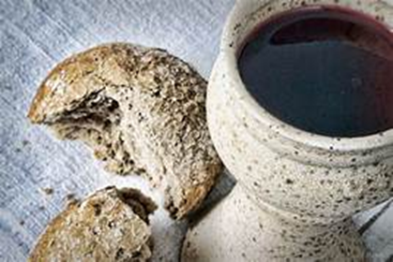
Because there is no Breaking and Sharing we can have only Spiritual Communion with Christ. I’m sure you can find a way to use a few minutes of silence or conversation to enjoy this, and make it a sacramental moment.

Giving thanks for Christ’s death and resurrection you may wish to say

Thanks be to you, Lord Jesus Christ,
for all the benefits you have given me,
for all the pains and insults you have borne for me.
Since I cannot now receive you sacramentally,
I ask you to come spiritually into my heart.
O most merciful redeemer, friend and brother,
may I know you more clearly,
love you more dearly,
and follow you more nearly, day by day. Amen.

Post Communion Collect

God of peace, whose Son Jesus Christ proclaimed the kingdom and restored the broken to wholeness of life: look with compassion on the anguish of the world, and by your healing power make whole both people and nations; through our Lord and Saviour Jesus Christ. Amen

Commission and Benediction
Send us out to be beacons of peace
in a dark world of conflict
Make us instruments of peace
for whoever we meet
and wherever we go,
In the name of the Prince of Peace,
Our Lord and saviour, Jesus Christ Amen.

Closing Music

‘In heavenly love abiding’
Words are on the screen.
https://www.youtube.com/watch?v=sT0r9DaGbmQ

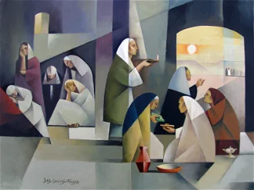

The Ten Virgins, by Jorge Cocco Santãngelo, 2012

